Obtaining information from the State Register of Individuals – Taxpayers on the amounts of paid income and withheld taxes in electronic form, certified by a qualified electronic seal of the State Tax Service.
Important! Request for amount of paid income can be formed starting from the 1st quarter of 1998 for any five years (request is formed quarterly, so the total number of quarters indicated in request should not exceed 20 quarters).

Select “Request for amounts of paid income”, click “+ Create”
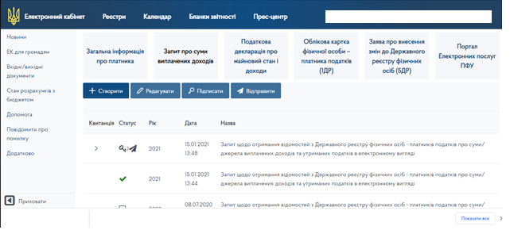

Check the correctness of filling in the requisites of request, enter information about address of residence, passport document and indicate period for which it is needed to obtain information. Save request.
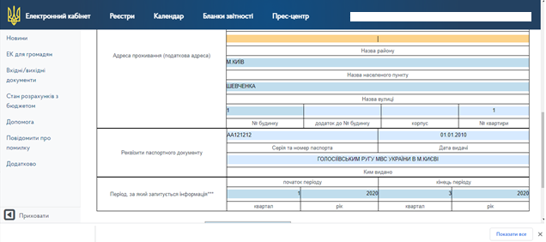

Sign the document with a Qualified Electronic Signature
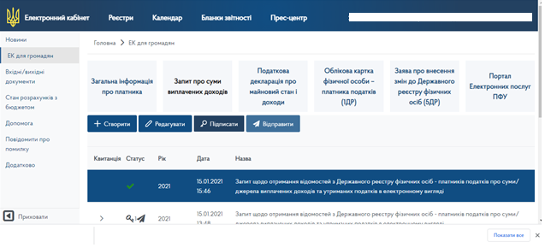
Choose file with Qualified Electronic Signature, click “Sign”
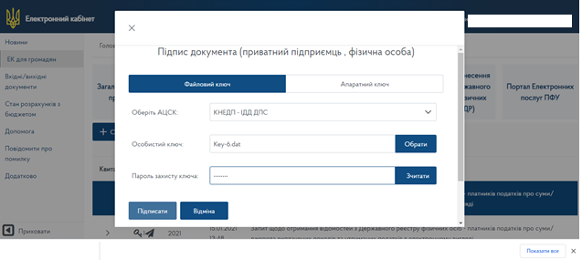

Request is signed
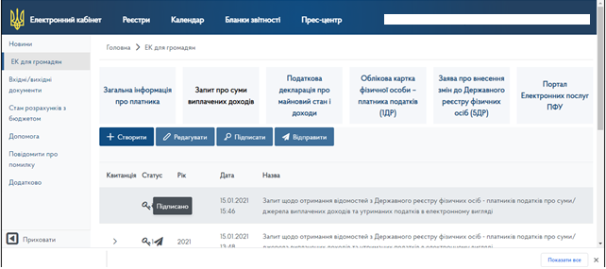

Click “Send”
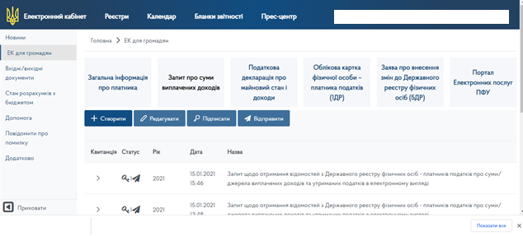
After a certain time you will receive:
Answer №1 – Notification on the acceptance of request;
Answer №2 – Information from the State Register of Individuals – Taxpayers on the amounts of paid income and withheld taxes.
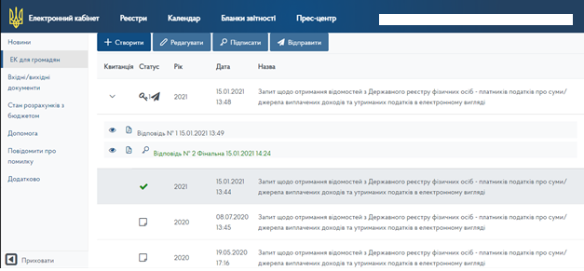

Information from the State Register of Individuals – Taxpayers on the amounts of paid income and withheld taxes can be:

- viewed without saving
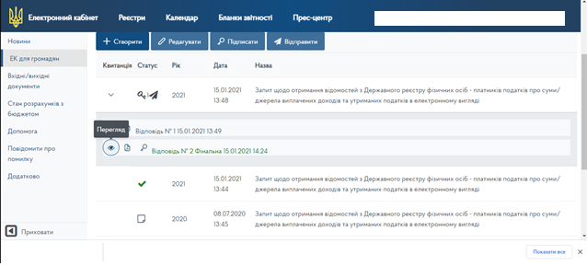

- downloaded the PDF format – information reference,

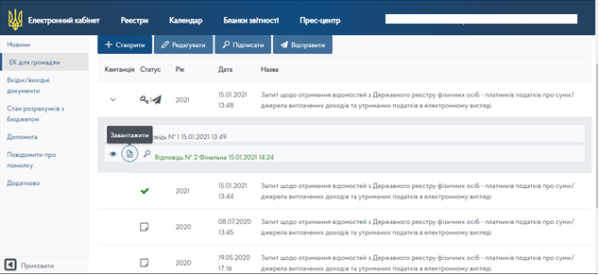

or applicant can download answer, certified by a qualified electronic seal of the State Tax Service.
Answer is downloaded in the form of a package that contains:
- answer to request in the electronic form (form F14018) in the PDF format
and
- file in format p7s, which contains a qualified electronic seal of the State Tax Service.

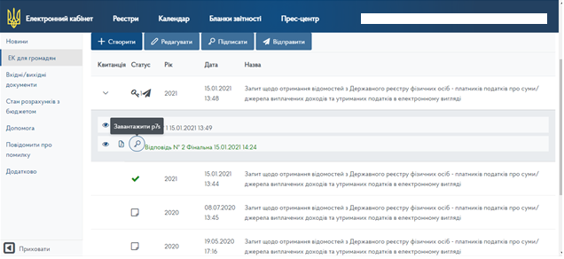

Verification of the authenticity of electronic document certified by the Qualified Electronic Signature – view instructions.

